ME 310 - Instrumentation and Theory of Experiments

Lab 1: Introduction to Oscilloscopes, Multimeters, Power Supplies,
And Function Generators

CONCEPTS: Analog oscilloscopes, Electrical measurements, Digital oscilloscopes, Digital multimeters, Power supplies, Function generators
DELIVERABLES: Pre-lab document, due in lab 1 period. Note that for this lab only, you are expected to write your own Procedure List.

- Introduction:

The objective of this lab is to teach how to use oscilloscopes and multimeters for measuring basic electrical quantities. You will also be introduced to additional lab equipment such as function generators and power supplies. This lab provides an introduction to the different methods by which measurements will be made in the remaining ME310 labs.

- Theory

  - Oscilloscopes

Oscilloscopes come in two main varieties: analog and digital. In this introductory lab, a digital storage oscilloscope (or DSO) will be used. Since the user interface to digital oscilloscopes is made to mimic the interface to the traditional analog version, analog oscilloscopes are described in detail in the first part of this section; digital oscilloscopes are described briefly in the final paragraph.

The main component of the analog oscilloscope is the cathode-ray tube (CRT). A CRT consists of an electron gun, an evacuated tube (typically made of glass with shape as indicated in Figure 1), and two pairs of metal parallel plates (one oriented in the horizontal direction and the other in the vertical direction) on which voltages can be placed. A fluorescent material is painted onto the inside of the flat portion of the tube. This portion of the tube is more commonly referred to as the ‘screen’ of the oscilloscope.

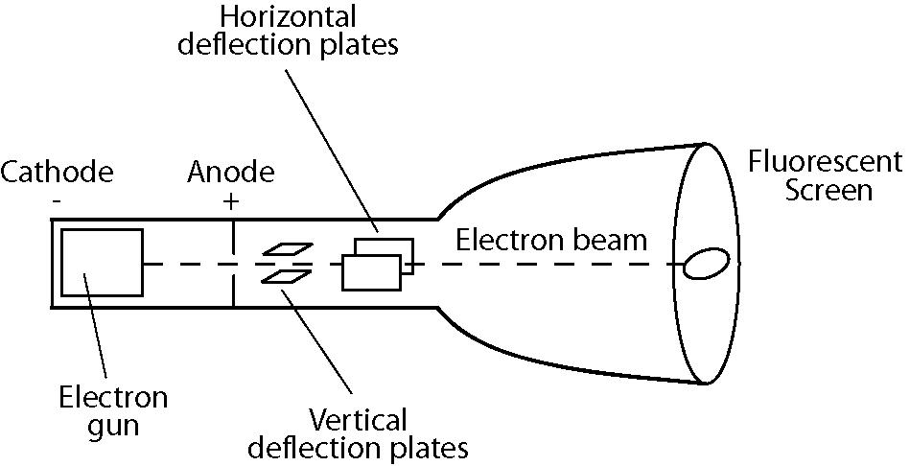

Figure 1: Sketch of cathode-ray tube.

The electron gun directs a beam of electrons down the tube towards the screen. Where the electron beam hits the screen, light is emitted due to the interaction of the beam with the fluorescent material. While passing though the tube, the beam is steered by the electric fields due to the voltages on the parallel plates. By placing the correct voltages on the plates, the beam can be directed to any position on the screen. The horizontally oriented plates deflect the beam in the vertical direction, and the vertically oriented plates deflect the beam in the horizontal direction. In Figure 1, the plates are labeled according to their function, not orientation.

Within the oscilloscope a voltage that increases linearly with time is generated. When applied to the vertically-oriented plates, the electron beam is caused to sweep horizontally across the face of the screen leaving a visible trace. If a second varying voltage is applied to the horizontal plates while the electron beam is moving horizontally, the beam will trace a graph of the time dependence of this varying signal. While the first voltage was generated inside the oscilloscope, the second one comes from outside the oscilloscope – it is provided by the measuring transducer being used. It is input to the oscilloscope at a connector on the oscilloscope’s front face. In this fashion, the screen of the scope displays a continuously updated ‘graph’ of voltage at the input on the vertical axis vs. time on the horizontal axis. When the beam reaches the edge of the tube (i.e. the right hand side of the screen as you face it) it is turned off and returned quickly to its starting position (the left hand side of the screen) to continue the trace of the input signal.

Triggering
One of the most important features of oscilloscopes (digital or analog) is their ability to synchronize the start of the beam sweep with a point of constant voltage (and thus a constant phase for periodic signals) from some reference (usually the input signal or other signal phase-locked with the input signal). This feature is known as triggering, and the constant voltage is known as the trigger voltage. Thus, periodic signals look stationary on the analog oscilloscope screen.

Digital Oscilloscopes
In contrast to analog oscilloscopes, the signal at the input of a digital oscilloscope does not directly control the deflection voltage on the horizontal plates. Instead the signal is first digitized and next displayed on the screen (a fact which must be recognized when interpreting traces displayed on a digital oscilloscope’s screen). Modern digital oscilloscopes employ LCD screens to display the acquired signal. Since digital oscilloscopes digitize the input signal, they have to ability to easily and continuously measure different properties of the signal such as RMS voltage (defined in Sec. 2.2.1), peak voltage, and frequency content.

  - Multimeters
    - Introduction to Multimeters
As their name suggests, multimeters have the ability to measure many different electrical quantities. The quantities that you will measure with a multimeter over the course of the ME 310 labs are: DC voltage, AC RMS (Root-Mean-Squared) voltage, DC current, and resistance.

Care must be taken when making an RMS measurement with a multimeter, as different meters perform the temporal average differently. The measurement of RMS voltage is discussed below; however all of the ideas presented also apply to RMS measurements of current.

To determine the RMS voltage of a signal, some multimeters actually measure the peak to peak voltage (defined as in Figure 2) and infer what the RMS level is. By assuming that the input signal is sinusoidal at a single frequency the RMS voltage can be calculated from this measurement (you need to find this expression as part of the pre-lab exercises – i.e. show how to calculate Vrms from Vpp).
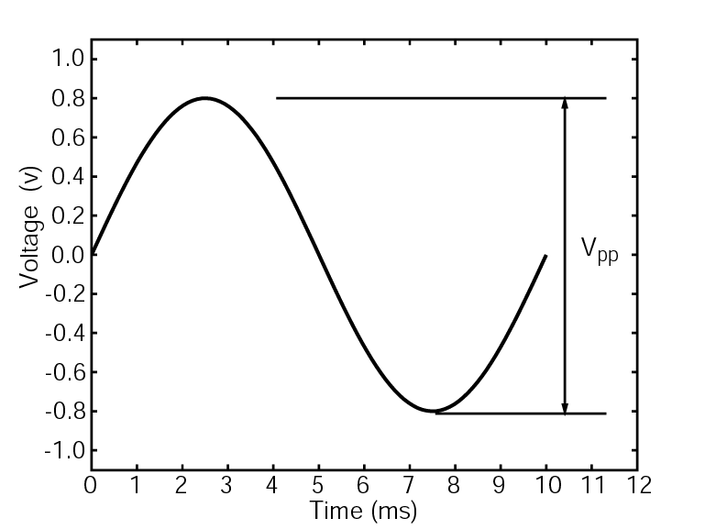
Figure 2: The peak to peak voltage of a signal is the voltage difference between the minimum voltage (at the trough) and the maximum voltage (at the crest). In this case, (a 100 Hz signal), the peak to peak voltage is 1.6 V.

Clearly this type of multimeter should only be used when the input signal satisfies these assumptions. Other multimeters measure what is known as ‘true’ RMS voltage. These meters measure the voltage by detecting the amount of heat dissipated by a resistor across which the voltage is placed. Meters of this kind can be used to measure the RMS voltage of any signal, including multi-frequency ones. The RMS value of a signal can also be found by digitally sampling a signal and applying the definition of root-mean-squared for a discrete signal:
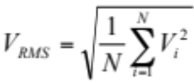 (1)

where N is the number of samples, and i denotes the i^{th} measurement.

    - Making a voltage measurement with a multimeter
If you want to measure the voltage across a component, i.e., a resistor, the multimeter must be connected in parallel with the resistor. To make an accurate measurement of the voltage across a component, the input impedance of the multimeter should be several orders of magnitude greater than the resistance across which the measurement is made. Suppose that the simple circuit in Figure 3 represents a flash light. The DC voltage source on the left is the battery and the resistor is the flash light bulb. You are interested in knowing the voltage across the bulb. To make this measurement, you must place the leads from the multimeter on either side of the bulb. More specifically, you must place the positive lead between the positive pole of the batteries and the bulb and place the negative lead between the bulb and the negative terminal of the batteries. Placing the probes in this configuration will ensure your measurement will have the correct magnitude and sign.
+
-
12.00 mV
Figure 3: To make a voltage measurement of voltage a across a circuit component with a multimeter, the meter must be placed in parallel with the component.

When measuring the RMS voltage of an AC signal with a multimeter, the probes must also be placed so that the meter is in parallel with the component. The orientation of the probes does not matter in this case as RMS voltage is always a positive quantity by definition.

    - Making a current measurement with a multimeter
In contrast to making voltage measurements, for which the multimeter was connected in parallel with the circuit, current measurements require the meter to be placed in series with the circuit. This is diagrammed below in Figure 4.
+
-
12.00 mA
Figure 4: To make a measurement of the current drawn by a circuit, the meter must be placed in series with the circuit.

Notice in Figure 4 that the portion of the circuit between the two probes has been removed. The idea is to make the current flow through the meter so it can be measured, and then return it to the circuit. For DC current measurements, the placement of the probes must follow the same rules as for DC voltage measurement. For AC current measurements the placement of the probes does not matter.

  - Function Generators
Function generators create time varying voltage signals, typically sine-, triangle-, and square-wave signals with varying voltage and frequency. Many current models include options for arbitrary waveform generation, frequency sweeps, pulses, and other features. A TRIG or SYNC output signal is commonly provided to synchronize other instrumentation with the periodic nature of the primary signal or pulse. Function generators are typically designed for use with equipment having a specified input impedance (50Ω or 1MΩ). If the equipment you are using with your function generator is not matched to the same output impedance, you must carefully measure and monitor the actual voltage amplitude delivered to the component you are driving with the function generator. In this case you cannot rely on the voltage amplitude displayed on the function generator’s display – it will not be the same as the voltage delivered to the equipment. Using equipment with input impedance less than the output impedance of a function generator requires the function generator to supply more current to the device than it is capable of, which could damage the function generator.

  - Power Supplies
Many measurement transducers require a bias voltage to operate. Typically the voltage is supplied by a DC power supply either integral to the transducer, or external to it. Most internal power supplies provide only one voltage. External supplies, however, can supply a range of voltages. Common ranges are ±6V, ±15V, and ±21V.

- Introduction to Equipment Used in ME 310 Labs

This section is intended to introduce the specific equipment that will be used in the ME 310 labs. The equipment is stored on rolling carts; each contains a digital oscilloscope, multimeter, function generator, and a power supply. Each cart also contains a computer that can be used for computerized data acquisition (not used during this first lab). When performing the labs, be sure to take note of which cart you are using, and also the model number and manufacturer of the equipment stored on it. The user manuals for each piece of equipment (the oscilloscope, multimeter, function generator, and power supply) are easily found online, through the manufacturer’s website.

  - Cables, Connectors and Adaptors
To make connections between two components (for example the function generator and the oscilloscope) a BNC cable with or without supplemental adaptors (depending on the two pieces of equipment being connected) will be used. BNC stands for Bayonet Neill-Concelman. Bayonet refers to the type of connector, and Neill and Concelman refer to the two engineers to who developed the connector in the late 1940’s. The male gender of the BNC connector (Figure 5), called the plug, has a pin in its center to mate with the hole at the center of the female connector.

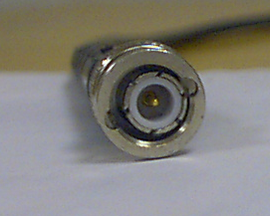

Figure 5: BNC Plug.
To provide a tight mechanical coupling between the plug and the socket, the BNC plug has a spring-loaded rotatable outer collar that contains two helical channels with notches at their ends. During connection, the channels guide the collar over two pins that stick out from the socket. When properly connected, the two notches at the ends of the helical channels rest on the pins on the socket. Wake up if you are falling asleep. The outer part of a BNC connector, usually silver in color, is connected to ground. The inner pin is isolated from ground by an insulating material, and carries the signal voltage.

The cable to which the BNC connectors are attached is called a coaxial cable. Coaxial cable is so named because of the arrangement of the signal and ground lines in the cable – they share a common center, therefore they are ‘coaxial.’ A cross section diagram of a coaxial cable is shown in Figure 6.
Outer Insulator
Ground Sheath
Inner Insulator
Signal lead

Figure 6: Cross section diagram of Coaxial Cable.

From outside in, a coaxial cable consists of an outer insulator, a ground sheath, a material to insulate the signal from ground (inner insulator), and the signal lead in the center. The ground sheath is typically made from braided wire. The signal lead can either be a stranded or solid wire. The outer part of a BNC connector is attached to the ground sheath, and the inner pin attaches to the signal lead. A coaxial cable is essentially two wires in one; if you understand this fact, you will have an easier time interpreting the wiring diagrams in this lab manual.

Another type of connector that you will use during the ME 310 labs is the dual-banana connector. Dual-banana plugs (plug will again refer the male gender of the connector) consist of two prongs that are inserted into the socket. A bump on the side indicates the banana plug that connects to the BNC ground connection of the BNC plug. Make sure to pay attention to where the ground prong plugs in.

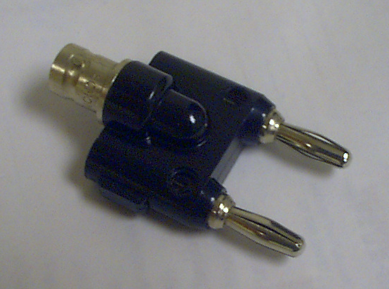
Figure 7: A dual banana to BNC adaptor.

You will also use what are known as BNC T’s. These devices are used to split the signal so that it can go to more than one place – for example, if you wanted to measure the voltage across the light bulb in the example with both an oscilloscope and a multimeter, then you would use a BNC T. Make sure to keep track of the impedances to which the T is connected. Not doing so will produce incorrect measurements.
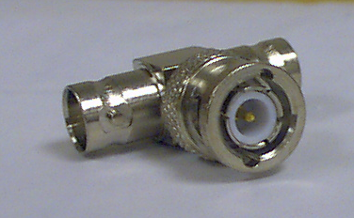
Figure 8: A BNC T.
The final connector with which you will become familiar are clip type connectors.

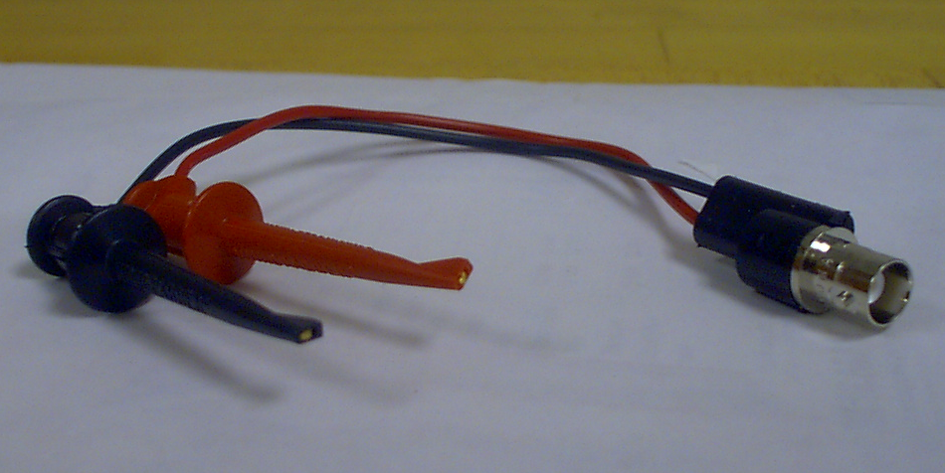

Figure 10: BNC to clip adaptor.

ME 310 labs use connectors with a spring loaded hook (Figure 10) which provide good mechanical and electrical connection, and minimize the amount of exposed conductor. This is their major advantage over alligator-type clips. Typically you will use a clip to BNC adaptor to connect a circuit to the oscilloscope, power supply or function generator. The red clip is connected to the center pin of the BNC connector, and the black clip is connected to the outer part, the ground, of the BNC connector.

  - Oscilloscopes
Raise your hand if you completed EK 307 with a thorough understanding of how to use an oscilloscope! ME310 labs employ LeCroy digital storage oscilloscopes (DSOs). They have two input channels and an input for a trigger signal. These connections to the oscilloscope (or ‘scope’ for short) are made via BNC sockets on the front face of the oscilloscope. There are additional connectors on the oscilloscope, including a USB port to allow computer communication for purposes of controlling the settings. Finally, another feature of these scopes is that they come equipped with a 10:1 signal attenuation probe. These probes can be used to examine signals with voltage amplitudes larger than the maximum rated input voltage of the oscilloscope.

The layout of the scope buttons and screen may be confusing at first, but (believe it or not!) the design is actually meant to make sense. The buttons for controlling the waveform acquisition and display are shown in Fig. 11. The BNC connectors are located along the bottom row, and immediately above appear three main categories: Vertical, Horizontal, and Trigger. ‘Vertical’ controls the voltage scaling and position for the signals on Ch 1 (left column) and Ch 2 (right column). ‘Horizontal’ controls the time base scaling and position, and the right-most column controls all the Trigger parameters.

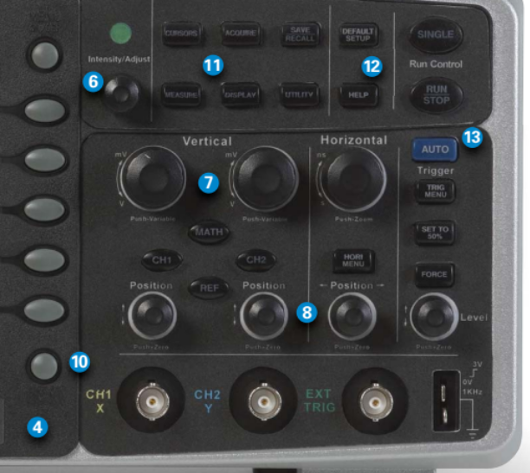
Figure 11: LeCroy WaveAce 212 panel layout.

There are a variety of trigger options, selected from the trigger menu, which you will explore during the lab exercise. Proper triggering of the waveform is often the most difficult step to perform. Since scopes are inherently used for measuring time-dependent signals, the triggering function is integral to establishing the correct time base that the digitized signal is displayed on. The displayed signal may be thought of as a dynamic graph, and the starting point of the signal needs to be set by properly using the trigger. The scope expects the trigger signal be unambiguous with regards to when the signal starts, so this is accomplished by providing a signal with a very fast transition, or slope, between voltage levels – either low to high (i.e., 0 to 3.3 V, a rising edge trigger) or vice versa (3.3 to 0 V, falling edge), all the order of a nanosecond. For this reason, the most common type of trigger is some type of square signal (most rapidly-transitioning signals will suffice as well). The scope has settings that allow the signal to be on any of the BNC input channels (as well as a digital signal transmitted via USB), to be either rising or falling edge, and to have any voltage level within the scope’s voltage range.

  - Multimeters
The multimeters are made by Keysight. In addition to having the ability to measure the quantities mentioned in Sec. 2.2, these multimeters can measure frequency (or period), do continuity tests and test diodes. The multimeter’s operation is controlled by the set of buttons on its front face. Connections to the meter are made via banana-plug sockets. There are sockets located on both the front and rear of the multimeter; to measure from the rear connections, the “front/rear” button must be set to “rear.” To measure from the front connectors, the button must be set to “front.” Care must be taken when connecting to the multimeter – follow the guides printed on the front face and rear.

To measure the (DC) voltage across a light bulb (in the example) the multimeter must be connected in parallel with the bulb. To begin, the multimeter should be set to measure DC voltage by pressing the appropriate button. Next, the connection to the circuit should be made; this is best done using a clip to BNC adaptor on either side if the bulb. The red clip should be placed between the positive pole of the battery and the bulb. The black clip should be placed after the bulb, and before the negative pole of the battery. Next, a BNC cable should be attached to the clip to BNC adaptor. Now the connection to the multimeter can be made via a BNC to dual-banana plug adaptor. Since voltage is being measured, the dual-banana connector should be plugged into the two upper right sockets, labeled “HI” and “LO”, below the word “Input.” The ‘V’ under “input’ stands for voltage. The ground side of the dual-banana connector (the side with the bump on it) must plug into the “LO” socket. Note that the equipment manual is available for the multimeter, and should be consulted if there is any doubt as to proper connections. You and your group are responsible for ensuring proper connections!

To measure the (DC) current drawn by the bulb first set the multimeter to measure DC current by pressing the appropriate button. Next, connect the circuit to the multimeter which must be made in series. As in the voltage measurement, a BNC cable with a clip to BNC adaptor on one end and BNC to dual banana adaptor on the other can be used to connect the bulb to the multimeter. Instead of placing the clips on either side of the bulb they must be placed on the same side, but without any wire from the circuit in between them. In written form, this description sounds awkward; however if you look at Fig. 4, you should be able to interpret its meaning unambiguously. The ground plug on the dual banana connector should be connected to the same socket as for measuring voltage; however, the other plug should be plugged into the socket labeled “I,” for current.

  - Function Generators
The function generators on the equipment carts are made by Keysight. The signal out and trigger signal are output via two separate BNC connectors on the front panel of the function generator. Operation of the function generator is controlled by the set of buttons on the front panel. In addition to providing sine, square and triangle waves at its output, these function generators can output pulses with varying duty cycles and also user-defined arbitrary waveforms generated on a PC.

The function generator’s default output impedance is 50Ω. As discussed in Sec. 2.3, the function generator will only display the correct delivered voltage to a component if that component has an input impedance of 50Ω. This is not to say that the function generator cannot drive a component with input impedance other that 50Ω. It simply means that you must independently monitor the voltage input to the component. As an example, if you connect the function generator to the oscilloscope directly (the oscilloscope has an input impedance of 1 MΩ) you would measure a different peak to peak voltage than what was displayed by the function generator (Discussion question: the value from the oscilloscope should be about two times that shown on the function generator; why?).

  - Power Supplies
The power supplies on the cart are made by Agilent. Connection to the power supply is made through dual banana connectors. This power supply provides 0-6 V on one set of banana sockets, and ±25 V on another. Both of them can be referenced to chassis ground by connecting to the green-colored banana socket. The operation is controlled via the set of buttons on the front panel of the power supply. These power supplies are equipped with current limiting circuitry to protect against some forms of potentially damaging incorrect use, such as short-circuiting. Always double-check your wiring set-up before connecting a power supply.
- Experimental Procedure

  - Using the Oscilloscope
    - Frequency Measurement
The first part of the experiment involves viewing the various waveforms generated by the function generator. Hook up the output of the function generator to the oscilloscope channel 2 input. Connect the function generator sync output to the external trigger input of the oscilloscope. Set the waveform in the function generator to sine, the frequency to 100 kHz, the amplitude to 1 Vpp (as displayed on the function generator), and the voltage offset to 30 mV. Now adjust the scope to view the signal in an appropriate scale.

SPOT CHECK: Using the settings in the time/div display on the scope screen, verify that the frequency in the scope matches the output frequency and voltage of the function generator. Will the scope make this measurement automatically for you? What is the peak-to-peak voltage of the wave on the oscilloscope? How does it compare to the voltage displayed by the function generator? Determine the offset voltage; is this possible to do with the grid lines on the oscilloscope display? If not, try using the oscilloscope cursors, and think through what the offset voltage represents, for a periodic signal.

Repeat the same procedure and spot check for square and triangular wave forms at 100 kHz with the same amplitude.

    - Voltage Measurement
The second part of the lab involves determining characteristic voltage parameters of a sinusoidal waveform. Set the function generator to output a 50 kHz sine wave with a 1 Vpp amplitude (as displayed on the function generator display) and no offset voltage. Observe the signal on the oscilloscope and determine the rms value of the voltage by measuring the peak to peak voltage of the signal. Also, enable the scope’s automatic measurement of the rms voltage. Compare your manual calculation with the value calculated by the scope. As part of the pre-lab, you should write down the formula for the rms voltage and also the method to determine it from the peak-to-peak voltage.

    - Phase Measurement
The third part of the experiment involves measuring the phase shift between two different signals. To generate the two signals you will use an RC circuit.

Build the circuit with a 121 Ω resistor and a 1 μF capacitor as shown in Figure 12. As an aid to interpreting the diagram, remember that the BNC cables you are using are two cables in one: the outer sheath is ground, and the inner conductor is the signal.

Measure the amplitude and phase shift of the output signal v_{o} measured across the capacitor for the following frequencies: 10k, 2k, 1000, 200, 100 (in Hz). v_{o} is the amplitude measured by channel 2 of the oscilloscope. Ensure that the measured input voltage amplitude, v_{i}, is maintained at 10 volts peak-to-peak. v_{i}, is the amplitude measured by channel one of the oscilloscope. The phase shift may be computed from the measured values of the time delay Δt and the signal period T, (defined as in Figure 13) by Eq. 2:
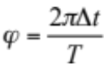 (2)

Oscilloscope
G
G
G
C2
C1
TR
Function Generator
SIG
TR
G
G
R
C
v_{i}
v_{o}

Figure 12: Wiring diagram for RC circuit. In the diagram ‘G’ stands for ground. On the function
generator, ‘SIG’ stands for signal out, and ‘TR’ stands for trigger signal out. On the oscilloscope, ‘C1’ refers to channel 1, ‘C2’ to channel 2, and ‘TR’ to trigger in. The dashed lines indicate the center conductor of the BNC cable, while the solid line indicates the outer sheath. The gray t-shaped box indicates a BNC T.
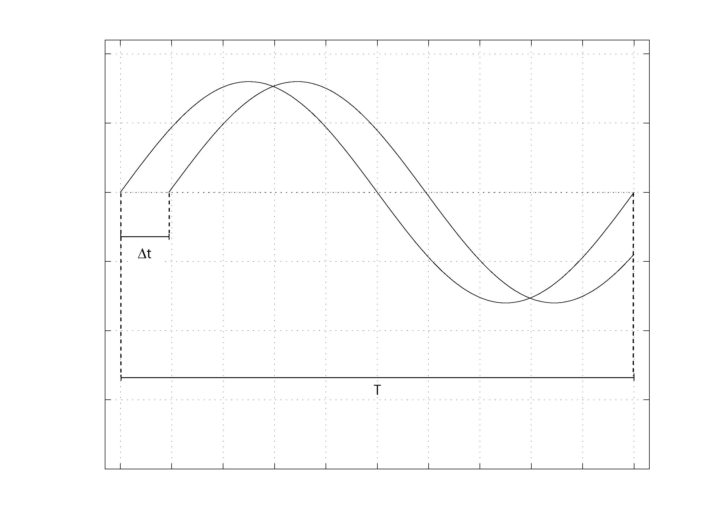
Figure 13: To compute the phase shift in radians use Eqn. 2, with time delay Δt and period T defined as in the figure.

    - Capacitance Measurement
Measure the capacitance C of the capacitor from your RC circuit. (Note: If you think of an alternate method for determining C, let the TF know and you may proceed with your method) You will not need to change any wiring in your circuit; however you will have to use a different resistor – the TF will provide you with one (somewhere around 1 kΩ). Measure this value of resistance yourself with a multimeter. One way to find the capacitance of your capacitor involves using Eq. 3, which describes the voltage across a capacitor (v_{c}) in an RC circuit in response to a step change in input voltage, as a function of time.

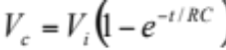 (3)

V_{i} is the amplitude of the step change in voltage input to the circuit (channel 2 of the oscilloscope), R is the resistance of the resistor, C is the capacitance of the capacitor, and t is the time after the step change in voltage. Using the oscilloscope, you can measure t, V_{c}, and V_{i}, and using the multimeter you can measure R (you will be instructed to do this in the next section), leaving C as the only unknown.

After switching the resistors, set the function generator to output a square wave with frequency near 80 Hz and amplitude 10 Vpp. The square wave will simulate the step change in voltage. Adjust the oscilloscope settings appropriately (this is your job!) so you can display the input signal and the voltage across the capacitor in a manner similar to Figure 14. Note that this is simply the charging curve of the capacitor circuit.
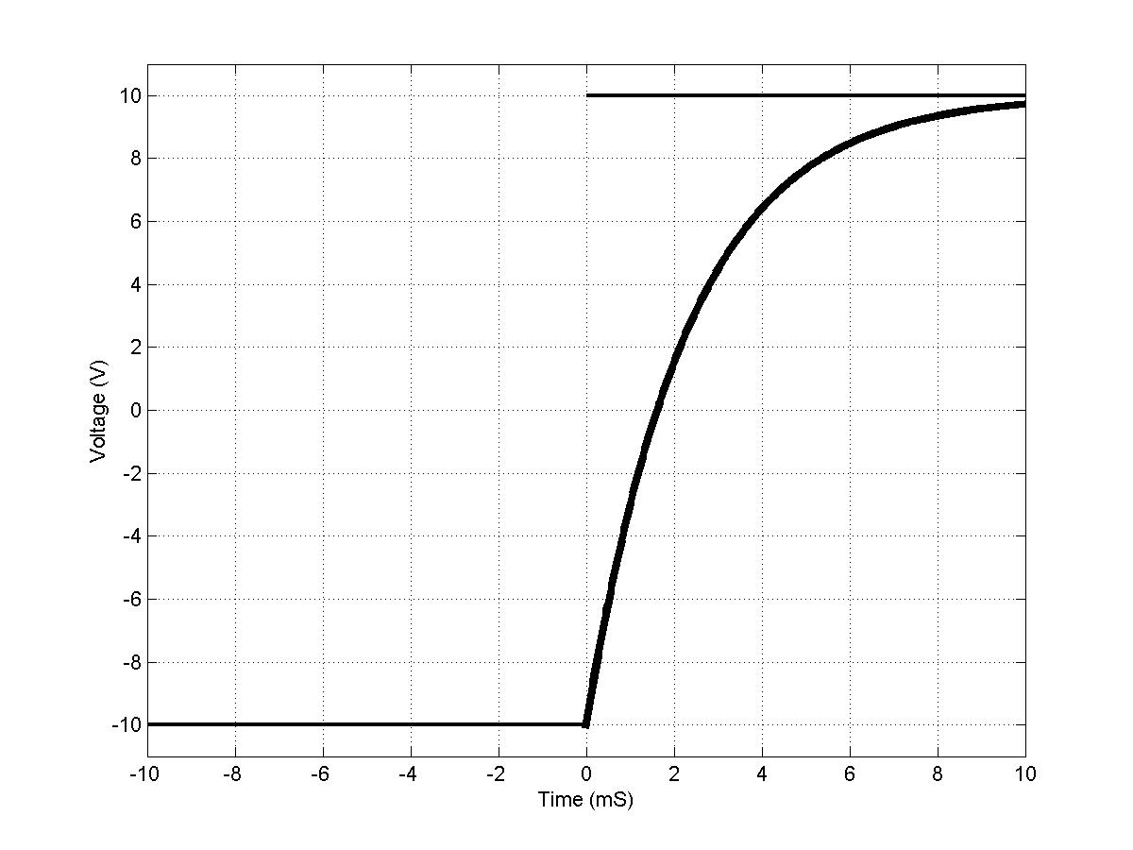
Figure 14: Sample oscilloscope trace for capacitance measurement.

Measure a t, v_{c} pair.

SPOT CHECK: Use Equation 3 to see if your measurements are close to the rated value of the capacitor (1 μF).

Once you are confident of your measurement technique, measure 4 more pairs of t and v_{c}. You should calculate the average from these 5 measurements to find the value of the capacitance of the capacitor. Draw a block diagram of the experimental setup (including the electrical signal connections between instruments) in your notebook.

4.1.5 Triggering in burst mode
A good way to understand how to properly trigger the scope is by looking at signals in burst mode. Up until now you’ve been looking at continuous wave signals, where the signal is a pure sinusoid in steady state.
Reconfigure the cable connections so as to return to the connection setup in Sec. 4.1.1. Disconnect the end of the BNC cable that is terminated to the scope’s ‘Ext Trig’ input port and instead terminate it into the Ch 1 input port on the scope. Be sure to activate Ch 1 so you can see the signal, and leave Ch 2 active and unchanged for its settings. On the function generator, change the output signal to burst mode by pressing the Burst button and set the output frequency to 1 kHz. Does the signal on the scope display look correct? If it’s not staying in place, then the scope doesn’t know when the signal is supposed to start. On the scope, push the ‘Trig Menu’ button, located on the column of buttons on the right side. Using the column of buttons located next to the display, select ‘Edge’ as the Type, ‘CH1’ as the Source, the up arrow for the Slope, and ‘Normal’ for the Mode. All these parameters will appear in orange text on the lower right corner of the display. When scope is successfully triggered, “Trig’d” will appear in green in the upper left corner of the screen, and the 1-cycle sinusoidal signal will stay in place. IF the scope isn’t properly triggered (it will instead display “Ready” in green), adjust the Trigger Voltage knob so that the voltage is between 0 and 3.3 V.

Increase the number of cycles in the burst to 10 cycles (via the ‘Burst’ button). Next, adjust the scope timebase so that all 10 cycles appear to their fullest temporal resolution on the display. How closely does the trigger signal line up with the start and stopping point of the pulse train? Adjust the Trigger Voltage knob to see how timing may be affected, based on the type of trigger signal.

Using the scope’s time base knobs, measure the time for the CH1 (trigger) between the first two pulses and calculate the Pulse Repetition Frequency (PRF). The PRF measures how often a given signal repeats itself in time.

  - Using the Multimeter and Power Supply
In this section of the experiment, the multimeter will be used to measure resistance, and voltage (AC and DC). You will measure the voltage across a resistor (whose resistance you will also measure) and the current drawn by that resistor. If done correctly the measured values should obey Ohm’s law.

    - Measuring Resistance
Connect a multimeter to the decade resistance box provided and change the resistance. Measure the resistance using the multimeter. Determine the error between the value shown by the decade box and the multimeter by selecting approximately 10 different combinations of rows and columns of values. Repeat this procedure until you feel you have a good estimate of the error for most rows and columns on the box.

Measure and record the resistance of the resistor given to you as part of the RC-circuit and the one you used to measure the capacitance, if you have not already done so.

    - Measuring Current and Voltage
SPOT CHECK: Check to see that your measurements satisfy Ohm’s law.
DC Power supply
G
G
⁺
Multimeter: DC I
I
LO
Multimeter: DC V
LO
R
V
Figure 15: Current and Voltage measurement wiring diagram (NOTE: ONLY ONE MULTIMETER IS USED; the figure shows the configuration for the separate current and voltage measurements).

The DC power supply will serve as the signal source and you’ll measure the voltage drop across a 50 Ohm resistor box (the GST will give you one) or via the decade resistance. Note that the power supply has multiple ground terminals (black ‘COMM’ terminal, green center terminal). Set the DC voltage on the ±25 V supply settings to 0.1 V by first connecting the ground termination to the black ‘COMM’ terminal, and measure the voltage on the multimeter. Note the voltage, and then switch the power supply ground termination to the green center terminal and measure the voltage again on the multimeter. Which method is correct? Once you’ve determined the proper termination setting, write it down in big letters in your lab notebook and measure the voltage for DC voltages of 0.1, 0.2 and 0.3 V, and next measure the current for the same DC voltage settings. Draw a block diagram of the experimental setup in your notebook.

SPOT CHECK: Check to see that your measurements satisfy Ohm’s law.

- Thought Questions
1. What are the percentage errors (i.e. for the sine, triangle and square wave) of the measured frequency in Section 4.1.1. relative to the indicated frequency?
2. Plot the amplitude ratio (v_{o}/v_{i}) of the low pass filter as a function of frequency.
3. Plot the phase difference as a function of frequency (on a separate set of axes from the axes in part 2.)
4. What is the average of your 5 measurements of capacitance from Section 4.1.4?

- Authors
Written by M Kanagavel (Jan 1999). Revised by RG Holt (Jan 1999); P Edson and RG Holt (Jan 2000, Aug 2001). Latest revision: C Farny (Jan 2019)

